**Course Mathematics Specialist Year 12**

Student name: ________________________ Teacher name: ________________

Date: 5 March 2021

**Task type: Take home - Investigation**

**Time allowed for this task: 1 week**

**Number of questions: 6**

**Materials required:** Calculator with CAS capability (to be provided by the student)

Standard items: Pens (blue/black preferred), pencils (including coloured), sharpener, correction fluid/tape, eraser, ruler, highlighters

Special items: Drawing instruments, templates, notes on one unfolded sheet of   
A4 paper, and up to three calculators approved for use in the WACE examinations

**Marks available:**

**Task weighting:**

**Formula sheet provided: Yes**

**Note: All part questions worth more than 2 marks require working to obtain full marks.**

**INSTRUCTIONS**

1. Take-home section will be allowed in the in-class investigation.

2. Your CAP is on next Friday, 12th March 2021. It will be 40 minutes long.

3. Only Classpad will be allowed for your in-class investigation.

Absolute value functions

1. 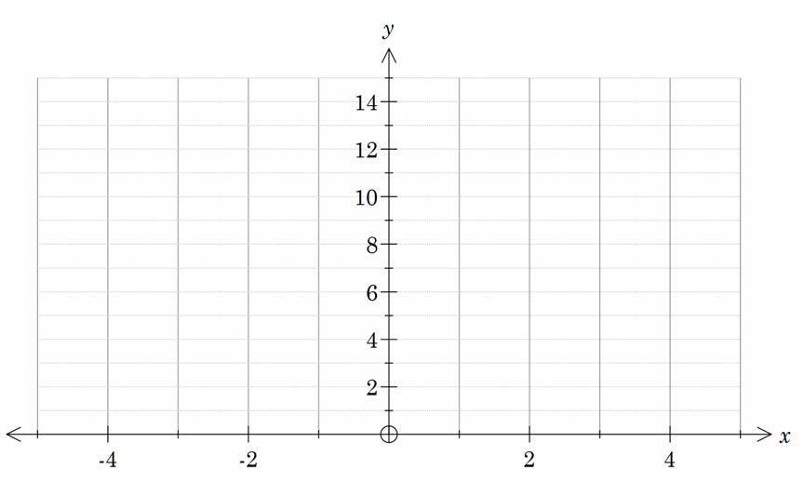Graph the function below. Label key features.
2. Express the function using a piecewise definition.
3. Explain the link between the gradient and intersection points of the different sections of the graph and the original absolute value equation.

Exploring Mathematics – Perth Arena

The design of Perth Arena is based on Christopher Monckton’s Eternity puzzle. The Eternity puzzle comprises of 209 irregular shaped pieces that fit on a dodecagon shaped board. A selection of these puzzle pieces was used to design the Perth Arena. Each puzzle piece represents Western Australian icons; Perth’s Trojan horse, a cockatoo, a drill rig, a sailing boat, truck referencing to mining industry, Rottnest island, a swan and Western Australia.

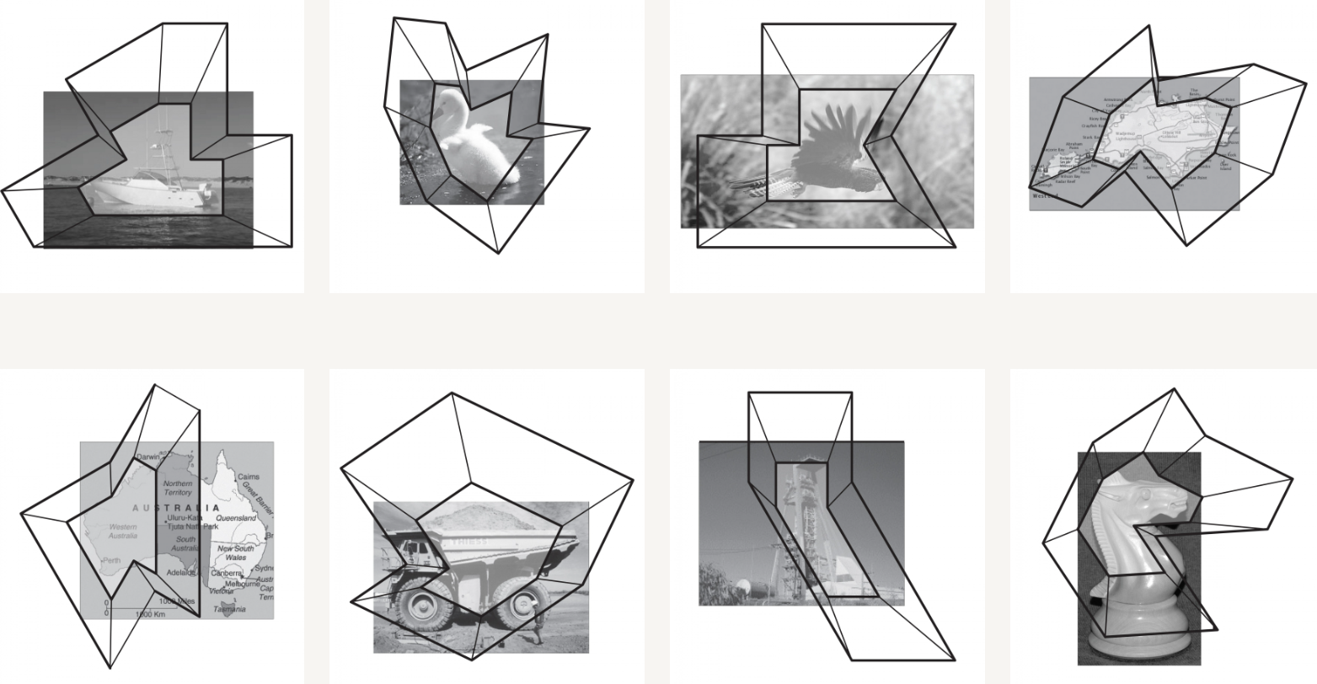

Your task is to determine a piecewise defined function and an absolute value function for one of the puzzle pieces given above. Due to the limitations of this course, we will determine function for only a part of the puzzle piece.

An example is shown below:

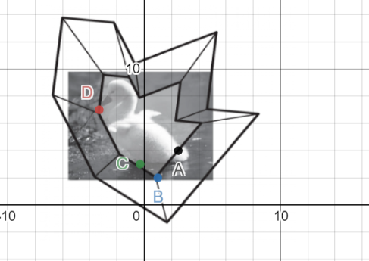

Desmos link : <https://www.desmos.com/calculator/xcxzril6fz>

1. Determine a piecewise-defined function to describe the part of swan puzzle piece.
2. Determine an equation of the form , to describe the part of swan puzzle piece.
3. Now, your task is to choose another puzzle piece and find an absolute function for the part of that puzzle piece. Use your findings from question 3 to decide the part of the puzzle. Use desmos graphing calculator to investigate the graphs of

You can use classpad or desmos to complete this activity. Some parts of the puzzle pieces are suggested below.

|  |  |  |
| --- | --- | --- |
| Puzzle Piece |  | Desmos link |
| Trojan Horse |  | <https://www.desmos.com/calculator/n0tjstkfmw> |
| Sailing Boat |  | <https://www.desmos.com/calculator/t4boxllhtn> |

**Solution**

Absolute value functions

1. Graph the function below. Label key features.

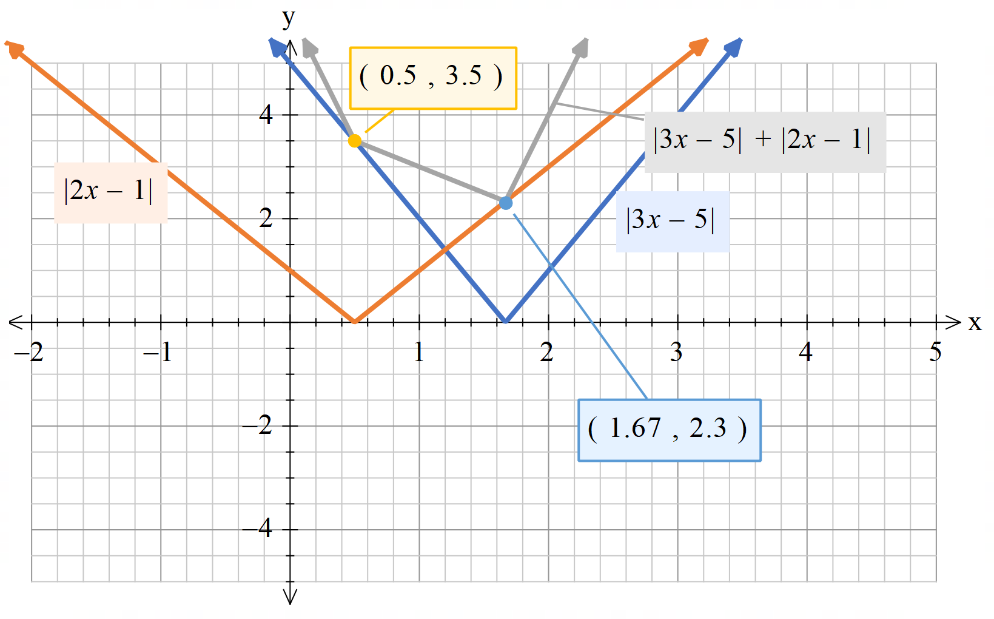

1. Express the function using a piecewise definition.

Piecewise function =

1. Explain the link between the gradient and intersection points of the different sections of the graph and the original absolute value equation.

**For puzzle piece - Swan**

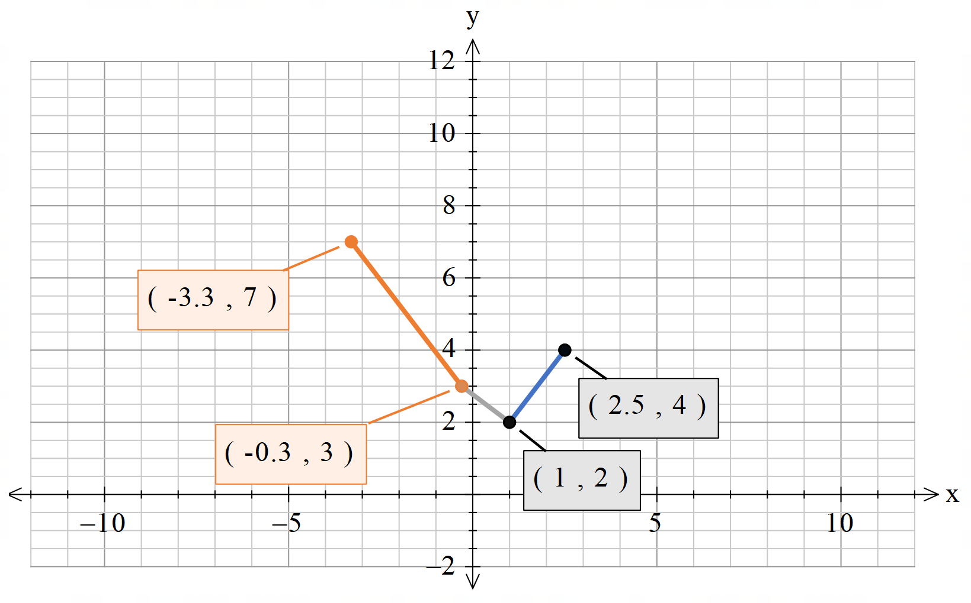

Orange line

Equation of line =>

Grey line

Equation of line =>

Blue line

Equation of line =>

Piecewise function =

Gradients =

When x = 0,

Solving equations

On desmos -- <https://www.desmos.com/calculator/qt4ldakjhc>

References

1. <https://archello.com/project/perth-arena-a-giant-puzzle-of-3d-architecture>
2. <https://armarchitecture.com.au/projects/rac-arena/>
3. <https://www.desmos.com/>